For Approvers
Time Off Approvals, Settings, and Allocation Management
SUMMARY
The purpose of this guide is to explain how managers and HR administrators review leave requests, configure carry-forward expiration rules, set up seniority-based accrual plans, and generate employee leave allocations. Automated email alerts and validation workflows streamline approvals, while expiration rules keep leave liability accurate.
PROCEDURE
Step 1 – Approver receives email alert and reviews pending leave request.
Step 2 – Approver validates or refuses the request with automatic notification to employee.
Step 3 – Administrator configures carry-forward expiry settings and accrual plans.
Step 4 – Administrator generates and manages employee leave allocations.
ADMIN GUIDE
Step 1. Reviewing and approving leave requests (For Managers & HR)
When an employee submits a leave request, you will receive an automated email notification.
Click "View Request ->" in the email to open the request directly, or navigate to "Time Off" -> "Management" -> "Time Off" (or Approvals).
Review the request details (employee name, leave type, dates, duration, description).
Take action:
• To Approve: Click "Approve" (or "Validate"). Note: If 2-step approval is enabled, the direct manager approves first, then the HR officer validates second.
• To Reject: Click "Refuse". The employee will receive an automated email notification.
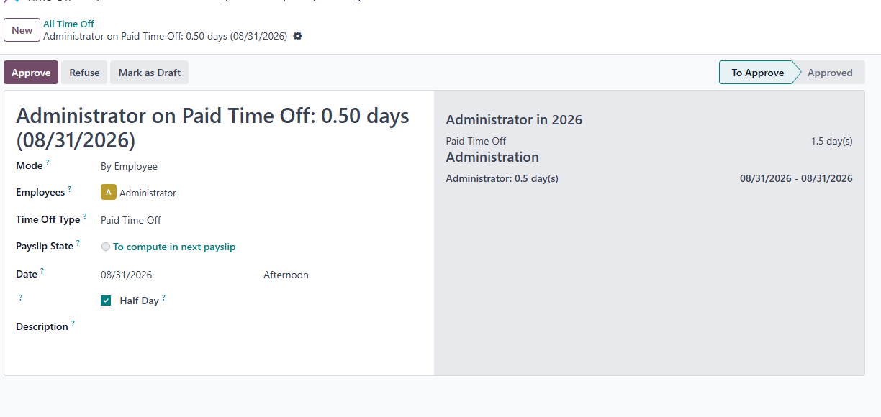
Step 2. Configuring carry-forward and expiry settings (For Admin)
Go to "Settings" -> "General Settings" -> scroll down to the "Time Off" section.
Configure the following settings:
• Carry Forward Expiry: Check the box to enable automatic expiry of carried-over balances.
• Expiry Date: Set the calendar expiration date (e.g., 30 April).
• Expiry Year: Select "Current Year" or "Next Year".
• Time Off Type: Select the default leave type (e.g., Paid Time Off).
• Accrual Plan: Select the default accrual plan.
• Carry Forward Generation Mode: Select "Previous Year Only", "Current Year Only", or "All Prior Years".
Click "Save" at the top-left to apply settings.
[IMAGE: Time Off General Settings Screen]
Step 3. Setting up accrual plans and expiry rules (For Admin)
Go to "Time Off" -> "Configuration" -> "Accrual Plans".
Click "New" (or open an existing plan).
Add or edit levels based on employee seniority milestones (e.g., 0-1 yr, 1-3 yrs, 3+ yrs from contract start date).
Configure the unused accruals policy:
• Unused Accruals: Set action to "Maximum" (to cap carried-over days) or "Lost".
• Carry-over Validity: Check the "Carry-over validity" checkbox.
• Valid for: Set the validity duration (e.g., 4 Months or 120 Days).
Click "Save". Carried-over leaves will automatically expire after the validity period.
[IMAGE: Accrual Plan Level Setup Screen]
Step 4. Generating carry-forward allocation for an employee (For Admin)
Go to the "Employees" app from the main menu.
Open the target employee profile.
In the top action bar, click the button: "Generate Carry Forward Allocation".
The system will:
• Calculate leave based on the employee's contract start date and configured accrual plan.
• Create and validate the allocation automatically.
• Open the newly created allocation record.
[IMAGE: Employee Profile Header with Generate Button]
Step 5. Required employee profile setup (For Admin)
Ensure the following fields are configured on the Employee profile for automation to work:
• Contract Start Date: Go to "Employees" -> select employee -> "Contracts" tab -> ensure "Start Date" is set (used for seniority calculation).
• Time Off Approver: Under "Work Information" tab -> set "Approver" (or Manager) for leave approval routing.
• Work Email: Under "Work Information" tab -> set "Work Email" for automated email notifications.
[IMAGE: Employee Work Information and Contract Tabs]

